AI Assisted Coding
2403A51355
BATCH -18

Task 1:
• Prompt GitHub Copilot to generate a Python script that collects user data (e.g., name, age,
email). Then, ask Copilot to add comments on how to anonymize or protect this data
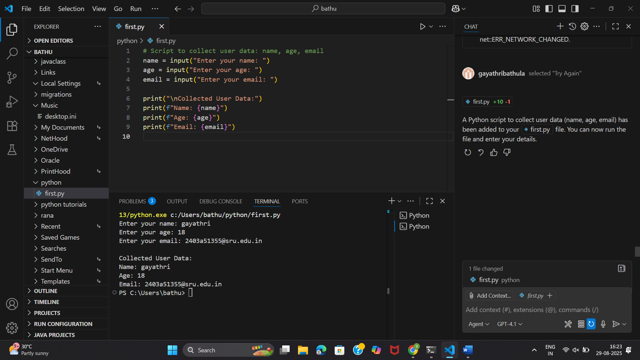
->after adding comments on how to anonymize or protect this data :
